**Project documentation**

**System requirements:**

**Hardware requirements:**

* + - Processor :intel core
    - Processor speed :13 GHz
    - Ram size : 1GB RAM(min)
    - Minimum disk size :250 GB space(min)

**Software requirements:**

* Databse :MySQL
* Front end: HTML5,CSS,BOOTSTRAP,JS.
* Backend:python,MySQl database
* Tools to install:
  + - * Xampp Server (latest vesion:7.4.27,8.0.14 etc)
      * Browser: chrome (latest version) or

Mozilla Firefox (latest version)

**Process or Steps to Run the Project:**

**Step 1:** download and install XAMPP server from <https://www.apachefriends.org/download.html> and start Apache and MySql servers.(running Xampp Server).

**Step 2:** Download and extract the zip file(Suprith-ks-project source code.zip).

After extracting the zip file we get “suprithks-sourcecode” folder and place this folder in path=“xampp\htdocs” folder.

**Step 3:** Open phpMyAdmin by visiting <https://localhost/phpmyadmin/> and go

To user accounts -> Add a user, give username:”root” , password:” ” (empty) and click on Check all next to global previleges and hit go.

Usually all the xampps account will have default username and password as above, if not then do the above process of adding a user.

**Step 4:** Next, create a new database named “person” (person database created).

**Step 5:** Select the person database and click on import and select person.sql file from the extracted folder and hit go. (now all the data in sql file is uploaded).

**Step 6:** Open your web browser and go to

[http://localhost/suprithks-sourcecode/firstpg.html or run firstpg.html](http://localhost/suprithks-sourcecode/firstpg.html%20%20or%20run%20firstpg.html) in localhost (xampps server) to access the web app.

**Screenshots :**



**Fig1: Dashboard page**

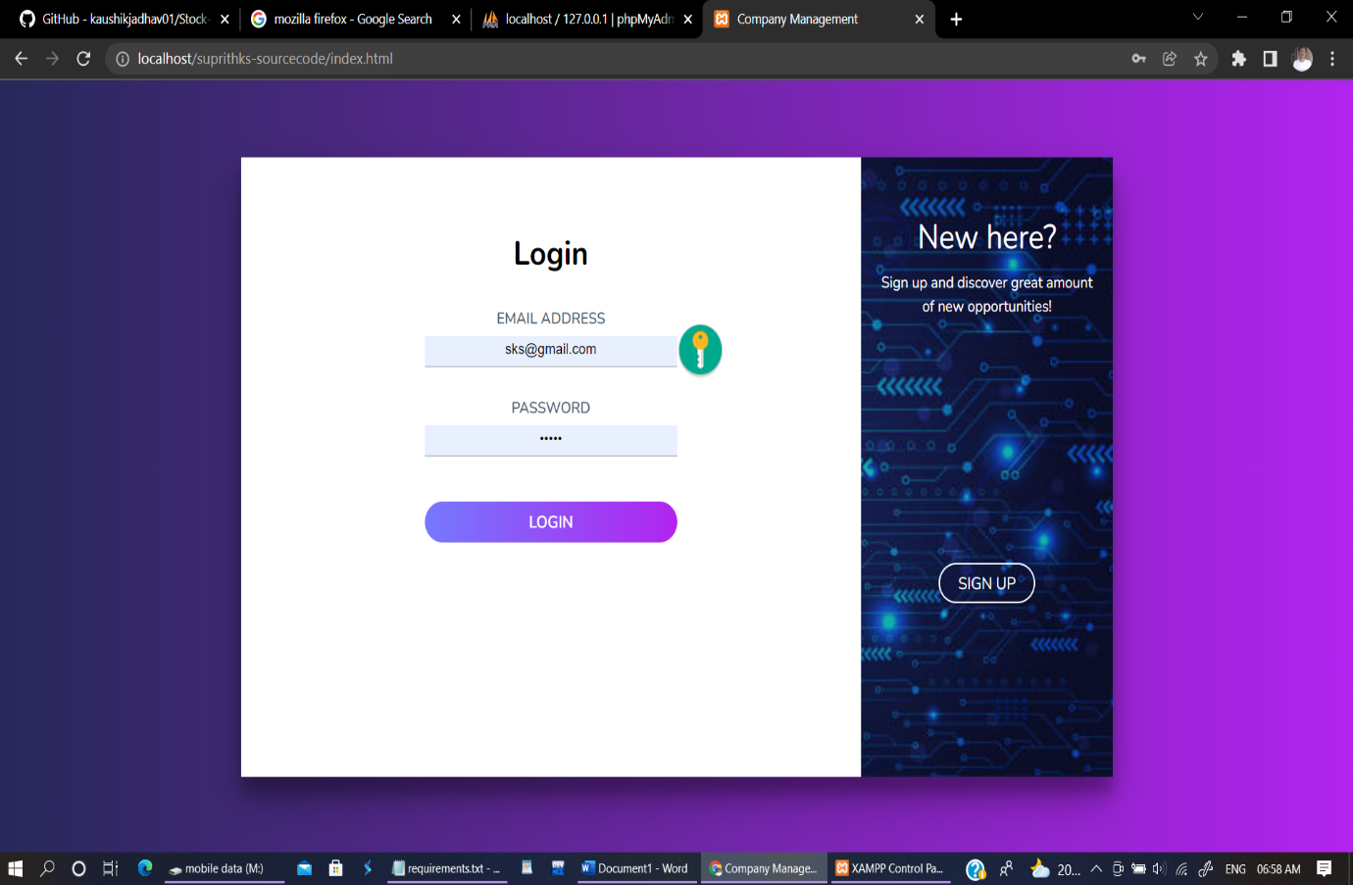

**Fig 2: Login page**

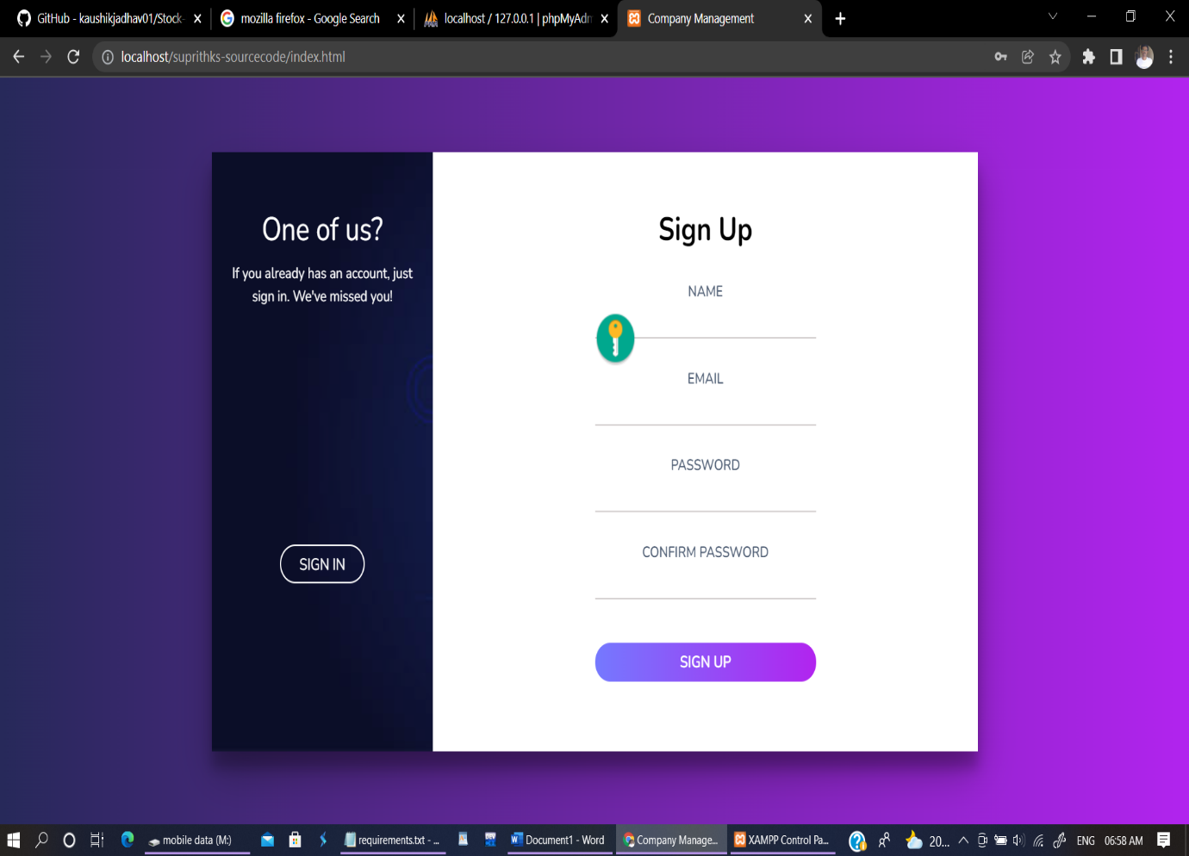

**Fig 3: Sign Up page**

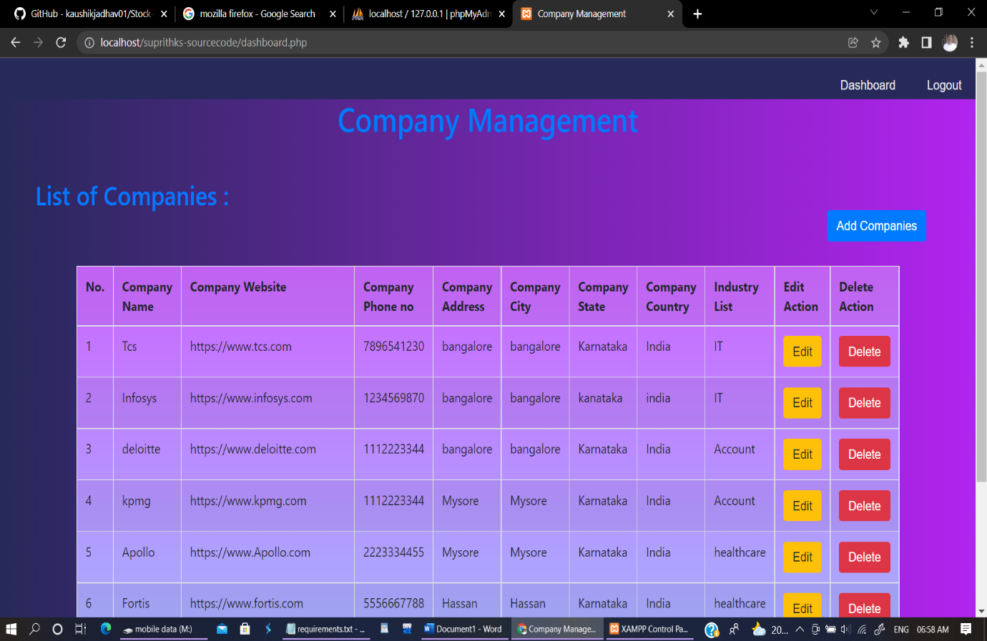

**Fig 4: List of Companies page**

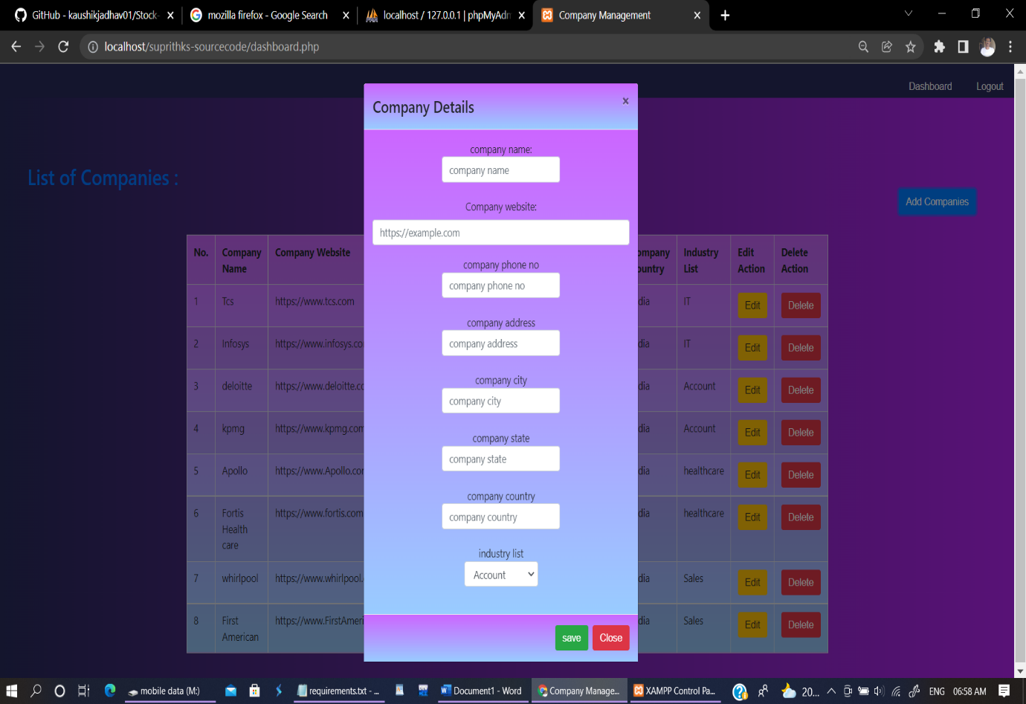

**Fig 5: Add company details page**

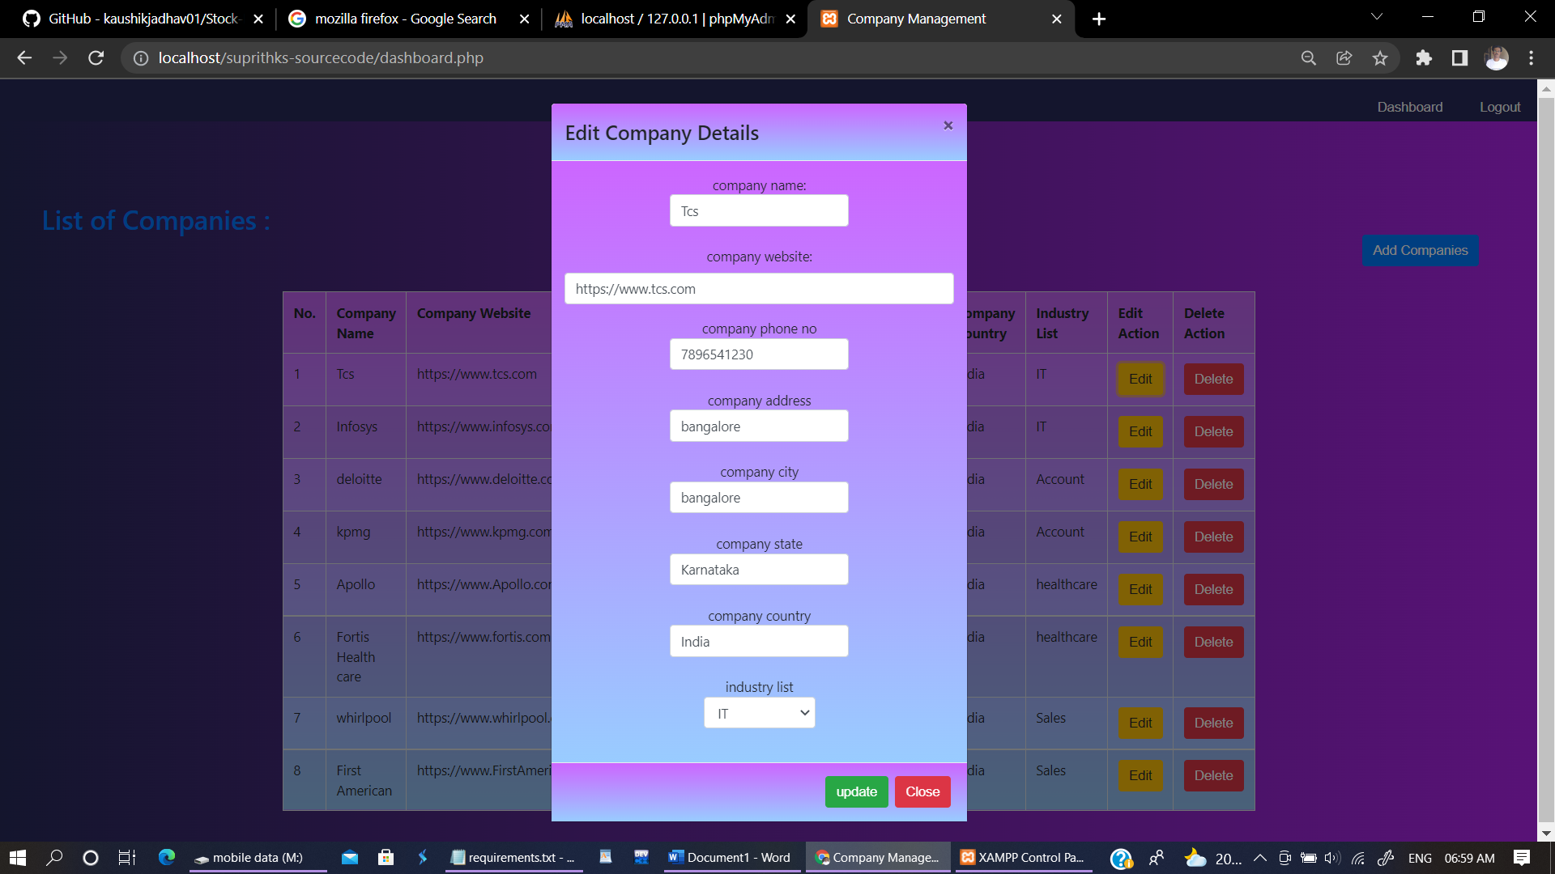

**Fig 6: Update company details page**